Supplementary materials
Comparison of immune response induced by nonreplicating adenoviruses formulation versus commercial pseudo-SARS-CoV-2
Joanna Baran¹, Łukasz Kuryk², Mariangela Garofalo³ , Katarzyna Pancer², Magdalena Wieczorek², Michalina Kazek^{1*}, Monika Staniszewska^{1*}
¹Centre for Advanced Materials and Technologies, Warsaw University of Technology, Warsaw, Poland
²National Institute of Public Health National Institute of Hygiene (NIH)—National Institute of Research, Warsaw, Poland
³Department of Pharmaceutical and Pharmacological Sciences, University of Padova, Padova, Italy
*e-mail: michalina.kazek@pw.edu.pl; monika.staniszewska@pw.edu.pl

Figure S1. Metabolic activity of PBMCs. Results from MTS assay, representative figure. Legend: Mock—LPS-treated cells (1.25 µg/mL), Pseudo-SARS-CoV-2—GeneCopoeia’s Lentifect™ SARS-CoV-2—Spike-pseudotyped lentivirus (100 VP/mL), Pseudo-SARS-CoV-2+Ab—pseudo-SARS-CoV-2 + SARS-CoV-2 Spike Antibody (GeneCopoeia; 100 VP/mL + 2.62 µg/mL), MIX1—AdV5/3-d24-ICOSL-CD40L + rRBD + pseudo-SARS-CoV-2 (100 VP/mL + 2.62 µg/mL + 100 VP/mL), MIX2—AdV5/3-d24-WT + rRBD + pseudo-SARS-CoV-2 (100 VP/mL + 2.62 µg/mL + 100 VP/mL). p-value > 0.05.

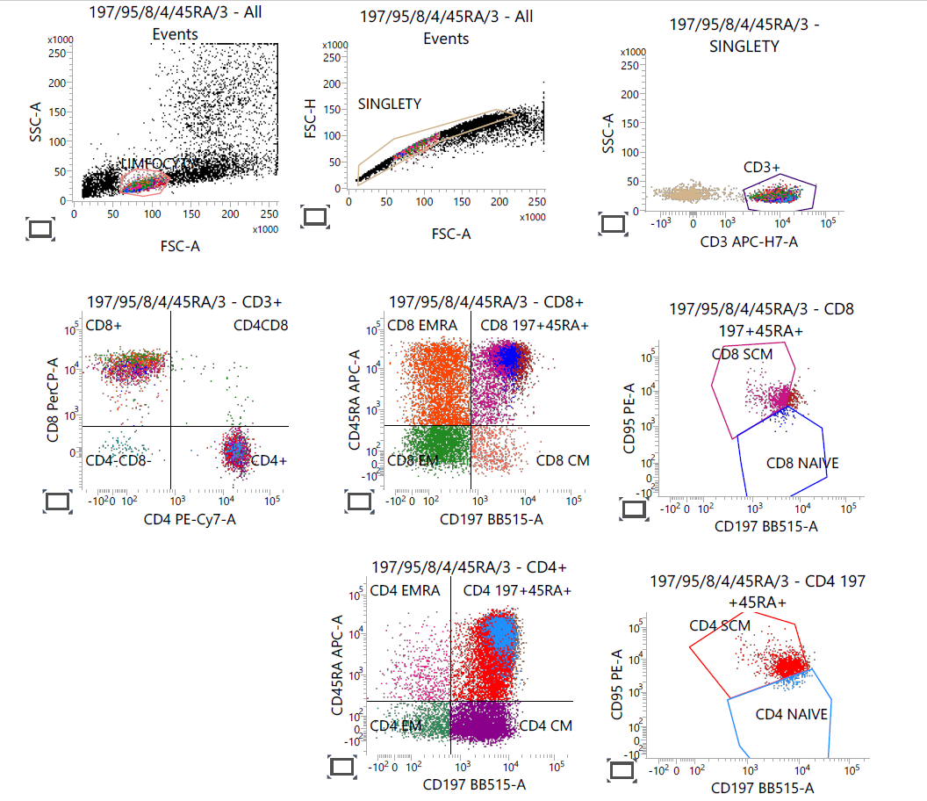
Figure S2. Gating strategy of T-cell panel—CD197, CD95, CD8, CD4, CD45RA, and CD3.
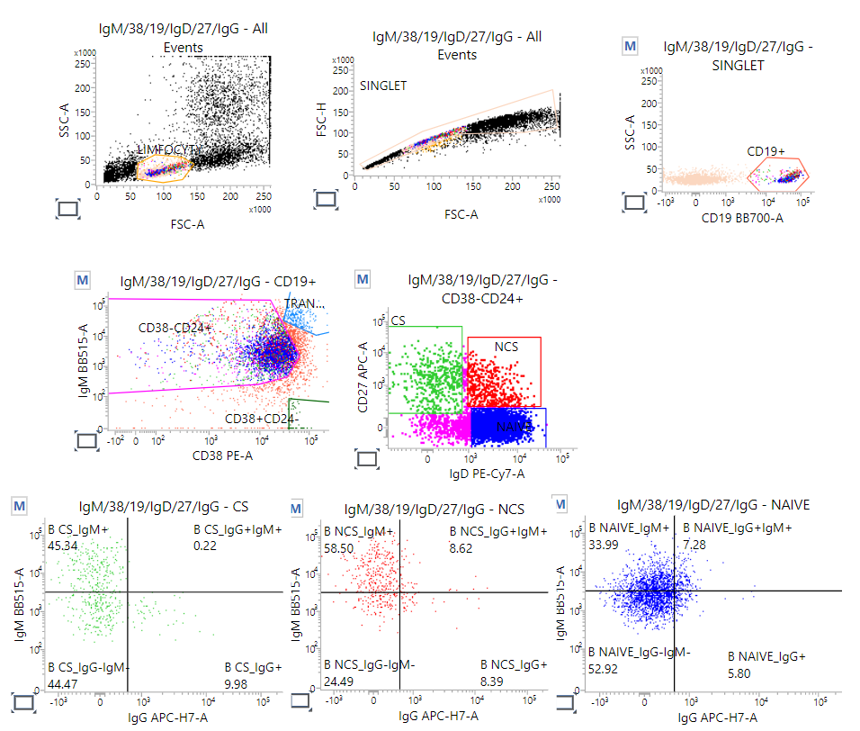
Figure S3. Gating strategy of B-cell panel—IgM, CD38, CD19, IgD, CD27, and IgG.
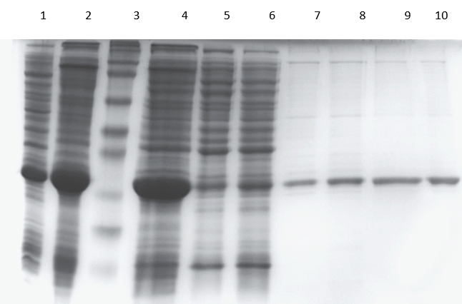
Figure S4. SDS-PAGE analysis of rRBD expression in E. coli and purification on NiNTA Sepharose SuperFlow chromatography.
Legend: Proteins were separated in 15% acrylamide gel and stained by Coomassie Brilliant Blue. Lanes: 1—Lysate of E. coli transformed with pT7/RBD plasmid; 2—Bacterial cell pellet after sonication; 3—Protein molecular marker (12.0–225.0 kDa) (Full-Range Rainbow, Amersham, UK); 4—Dissolved inclusion bodies (50 mM phosphate buffer, 5 mM β-mercaptoethanol, 7 M urea pH 12.0); 5—Protein unbound to NiNTA Sepharose column; 6—Fractions after washing (50 mM phosphate buffer pH-7.0, 7 M urea, 300 mM NaCl, 25 mM imidazole); 7, 8, 9—Fractions eluted from NiNTA Sepharose column (50 mM phosphate buffer pH 7.0, 7 M urea, 300 mM NaCl, 300 mM imidazole); and 10—rRBD protein after elution and 24 h dialysis (50 mM phosphate buffer pH 8.0, 10% glycerol).

Table S1. Percentage of the CD38⁻CD24⁺ cell subpopulations measured by flow cytometry (FACS Lyric, BD Biosciences, NJ, USA).
B cell subsets |  | Immunogenic factors
 |  | Mock |  | Pseudo-SARS-CoV-2 |  | Pseudo-SARS-CoV-2 + Ab |  | MIX1 |  | MIX2
CS | IgM⁺ |  | 32.50 ± 3.04 |  | 29.81 ± 1.55 |  | 40.40 ± 2.46 |  | 23.50 ± 2.50 |  | 29.49 ± 1.77
CS | IgG⁺IgM⁺ |  | 0.10 ± 0.14 |  | 0.11 ± 0.16 |  | 0.08 ± 0.12 |  | 5.01 ± 2.00 |  | 2.24 ± 0.54
CS | IgG⁻IgM⁻ |  | 51.04 ± 1.96 |  | 51.50 ± 1.30 |  | 53.29 ± 0.21 |  | 40.78 ± 7.36 |  | 48.25 ± 0.27
CS | IgG⁺ |  | 16.37 ± 1.32 |  | 18.59 ± 2.71 |  | 6.23 ± 2.38 |  | 30.71 ± 7.83 |  | 20.02 ± 1.72
NCS | IgM⁺ |  | 56.76 ± 1.47 |  | 56.99 ± 4.08 |  | 66.17 ± 1.90 |  | 29.29 ± 10.02 |  | 38.25 ± 1.70
NCS | IgG⁺IgM⁺ |  | 7.49 ± 0.31 |  | 6.78 ± 0.68 |  | 4.14 ± 0.64 |  | 19.99 ± 8.70 |  | 8.55 ± 1.52
NCS | IgG⁻IgM⁻ |  | 31.92 ± 1.68 |  | 32.02 ± 2.69 |  | 27.40 ± 1.90 |  | 31.75 ± 6.79 |  | 44.01 ± 3.62
NCS | IgG⁺ |  | 3.83 ± 0.38 |  | 4.21 ± 0.73 |  | 1.80 ± 0.74 |  | 19.31 ± 8.37 |  | 9.19 ± 0.81
NAÏVE | IgM⁺ |  | 21.49 ± 2.01 |  | 24.28 ± 0.92 |  | 30.11 ± 2.71 |  | 16.17 ± 3.08 |  | 20.05 ± 1.16
NAÏVE | IgG⁺IgM⁺ |  | 6.18 ± 0.98 |  | 6.44 ± 0.44 |  | 3.85 ± 0.72 |  | 7.92 ± 2.54 |  | 4.11 ± 0.25
NAÏVE | IgG⁻IgM⁻ |  | 65.13 ± 3.41 |  | 63.14 ± 1.48 |  | 63.59 ± 1.64 |  | 65.98 ± 3.84 |  | 71.85 ± 0.87
NAÏVE | IgG⁺ |  | 7.20 ± 0.74 |  | 6.14 ± 0.34 |  | 2.44 ± 0.46 |  | 9.93 ± 4.42 |  | 3.98 ± 0.69
Legend: PBMCs were treated for 24 h in vitro with the following immunogenic factors: Mock—LPS-treated cells (1.25 µg/mL), Pseudo-SARS-CoV-2—GeneCopoeia’s Lentifect™ SARS-CoV-2 Spike-pseudotyped lentivirus (100 VP/mL), Pseudo-SARS-CoV-2+Ab—pseudo-SARS-CoV-2 + SARS-CoV-2 Spike Antibody (GeneCopoeia; 100 VP/mL+2.62 µg/mL), MIX1—AdV5/3-d24-ICOSL-CD40L + rRBD + pseudo-SARS-CoV-2 (100 VP/mL + 2.62 µg/mL + 100 VP/mL), MIX2—AdV5/3-d24-WT + rRBD + pseudo-SARS-CoV-2 (100 VP/mL + 2.62 µg/mL + 100 VP/mL). CS means class switched subpopulation of CD38⁻CD24⁺, NCS means nonclass switched subpopulation of CD38⁻CD24⁺, NAÏVE means cells unexposed to immunogenic factors. The data are representative of 2–4 independent experiments. Bolded numbers p-value ≤ 0.05.

Table S2. Percentage of different CD4⁺ subpopulations measured by flow cytometry (FACS Lyric, BD Biosciences, NJ, USA).
CD4⁺ subpopulations | Immunogenic factor
CD4⁺ subpopulations | Mock | Pseudo-SARS-CoV-2 | Pseudo-SARS-CoV-2 +Ab | MIX1 | MIX2
CD4⁺ subpopulations | (%)
CD197⁺CD45RA⁺ | 74.23 ± 10.28 | 70.40 ± 8.08 | 75.93 ± 4.16 | 67.30 ± 6.85 | 44.60 ± 9.62
NAÏVE | 50.30 ± 6.35 | 40.47 ± 5.30 | 41.20 ± 10.74 | 53.67 ± 7.42 | 38.73 ± 7.73
SCM | 23.03 ± 5.03 | 28.67 ± 8.06 | 34.03 ± 7.13 | 13.20 ± 0.99 | 5.70 ± 1.98
CM | 17.40 ± 4.52 | 17.97 ± 3.63 | 16.33 ± 2.46 | 18.73 ± 2.33 | 19.07 ± 0.47
EM | 5.70 ± 3.89 | 7.40 ± 2.83 | 5.00 ± 1.56 | 11.10 ± 4.10 | 26.70 ± 9.19
EMRA | 2.63 ± 1.96 | 4.23 ± 1.67 | 2.70 ± 1.70 | 2.83 ± 0.74 | 9.63 ± 0.90
Legend: PBMCs were treated for 24 h in vitro with the following immunogenic factors: MOCK—LPS-treated cells (1.25 µg/mL), Pseudo-SARS-CoV-2—GeneCopoeia’s Lentifect™ SARS-CoV-2 Spike-pseudotyped lentivirus (100 VP/mL), Pseudo-SARS-CoV-2+Ab—pseudo-SARS-CoV-2 + SARS-CoV-2 Spike Antibody (GeneCopoeia; 100 VP/mL + 2.62 µg/mL), MIX1—AdV5/3-d24-ICOSL-CD40L + rRBD + pseudo-SARS-CoV-2 (100 VP/mL + 2.62 µg/mL + 100 VP/mL), MIX2—AdV5/3-d24-WT + rRBD + pseudo-SARS-CoV-2 (100 VP/mL + 2.62 µg/mL + 100 VP/mL). CS means class switched subpopulation of CD38⁻CD24⁺, NCS means nonclass switched subpopulation of CD38⁻CD24⁺, NAÏVE means cells unexposed to immunogenic factors. Bolded number means p value ≤ 0.05.
Table S3. CD8⁺ subpopulations were measured by flow cytometry (FACS Lyric, BD Biosciences, NJ, USA).
CD8⁺ subpopulations | Immunogenic factor
CD8⁺ subpopulations | Mock | Pseudo-SARS-CoV-2 | Pseudo-SARS-CoV-2  +Ab | MIX1 | MIX2
CD8⁺ subpopulations | (%)
CD197⁺ CD45RA⁺ | 52.2 ± 4.54 | 50.07 ± 2.15 | 46.07 ± 7.95 | 38.07 ± 7.29 | 23.53 ± 3.21
NAÏVE | 32.47 ± 6.35 | 29.9 ± 5.30 | 25.1 ± 10.74 | 29.57 ± 7.42 | 21.27 ± 7.73
SCM | 10.63 ± 5.03 | 14.33 ± 8.06 | 14.93 ± 7.13 | 6.83 ± 0.99 | 2.27 ± 1.98
CM | 4.53 ± 1.16 | 3.2 ± 0.83 | 3.23 ± 1.14 | 3.07 ± 1.14 | 1.33 ± 0.05
EM | 7.23 ± 1.86 | 7.43 ± 1.06 | 7.67 ± 2.89 | 12.87 ± 3.68 | 17.53 ± 6.27
EMRA | 36.03 ± 3.20 | 39.3 ± 2.34 | 43.07 ± 5.72 | 46.00 ± 5.76 | 57.57 ± 3.16
Legend: PBMCs were treated for 24 h in vitro with the following immunogenic factors: MOCK—LPS-treated cells (1.25 µg/mL), Pseudo-SARS-CoV-2—GeneCopoeia’s Lentifect™ SARS-CoV-2—Spike-pseudotyped lentivirus (100 VP/mL), Pseudo-SARS-CoV-2+Ab— pseudo-SARS-CoV-2 + SARS-CoV-2 Spike Antibody (GeneCopoeia; 100 VP/mL + 2.62 µg/mL), MIX1—AdV5/3-d24-ICOSL-CD40L + rRBD + pseudo-SARS-CoV-2 (100 VP/mL + 2.62 µg/mL + 100 VP/mL), MIX2—AdV5/3-d24-WT + rRBD + pseudo-SARS-CoV-2 (100 VP/mL + 2.62 µg/mL + 100 VP/mL). EMRA means terminally differentiated effector memory cells re-expressing CD45RA; NAÏVE means cells unexposed to immunogenic factors; SCM means stem-cell-like cells; CM means central memory cells; EM means effective memory cells. Bolded number means p value ≤ 0.05.
Table S4. Sequence of rRBD.
Source: https://www.ncbi.nlm.nih.gov/nuccore/1798174254

/organism=“Severe acute respiratory syndrome coronavirus
2”
/isolate=“Wuhan-Hu-1”
/host=“Homo sapiens”
/country=“China”
/collection_date=“Dec-2019”
- aminoacid sequence

5ʹ Met + RBD + FT4 + SerGlySer + 6HisTag + STOP 3ʹ (232 aa = 696 bp)

MNITNLCPFGE VFNATRFASV YAWNRKRISN CVADYSVLYN SASFSTFKCY GVSPTKLNDL CFTNVYADSF VIRGDEVRQI APGQTGKIAD YNYKLPDDFT GCVIAWNSNN LDSKVGGNYN YLYRLFRKSN LKPFERDIST EIYQAGSTPC NGVEGFNCYF PLQSYGFQPT NGVGYQPYRV VVLSFELLHA PATV GYIPEAPRDG QAYVRKDGEW VLLSTFL SGSHHHHHH+ STOP

- nucleotide sequence (codon usage E. coli)

5ʹ ATG AAC ATT ACC AAC CTG TGC CCG TTC GGC GAA GTG TTC AAC GCG ACC AGA TTC GCG TCT GTG TAT GCG TGG AAC CGT AAA CGT ATT TCT AAC TGC GTG GCG GAT TAT TCT GTG CTG TAT AAC TCT GCG TCT TTT TCT ACC TTT AAA TGC TAT GGC GTG TCT CCG ACC AAA CTG AAC GAT CTG TGC TTT ACC AAC GTG TAT GCG GAT TCT TTT GTG ATT CGT GGC GAT GAA GTG CGT CAG ATT GCG CCG GGC CAG ACC GGC AAA ATT GCG GAT TAT AAC TAT AAA CTG CCG GAT GAT TTT ACC GGC TGC GTG ATT GCG TGG AAC TCT AAC AAC CTG GAT TCT AAA GTG GGC GGC AAC TAT AAC TAT CTG TAT CGT CTG TTT CGT AAA TCT AAC CTG AAA CCG TTT GAA CGT GAT ATT TCT ACC GAA ATT TAT CAG GCG GGC TCT ACC CCG TGC AAC GGC GTG GAA GGC TTT AAC TGC TAT TTT CCG CTG CAG TCT TAT GGC TTT CAG CCG ACC AAC GGC GTG GGC TAT CAG CCG TAT CGT GTG GTG GTG CTG TCT TTT GAA CTG CTG CAT GCG CCG GCG ACC GTG GGC TAT ATT CCG GAA GCG CCG CGT GAT GGC CAG GCG TAT GTG CGT AAA GAT GGC GAA TGG GTG CTG CTG TCT ACC TTT CTG TCT GGT TCT CAT CAC CAT CAT CAC CAT TAA 3ʹ

